LAB ASSIGNMENT
Call by Value and Call by Reference

1. Lab Objectives
- Understand how function arguments are passed in C.
- Differentiate between passing ordinary variable values and passing pointer values to functions.
- Use pointers to modify variables in the calling function.
- Design functions that return results using return values and pointer parameters.
- Apply functions and pointers to problems involving swapping, calculations, arrays, and data updates.

2. Topic Overview

Call by Value
In call by value, a function receives a copy of an argument’s value. Changes made to the function parameter do not change the original variable in the calling function. This is useful when a function needs to work with input data without modifying the caller’s variable.

Call by Reference (Using Pointers in C)
C passes all function arguments by value. What is commonly called “call by reference” in C is implemented by passing a pointer to a variable. The function receives the address and can modify the original object by dereferencing the pointer with the * operator. The address operator (&) is used to pass a variable’s address.

Key Difference
Call by Value | Pointer-Based Modification
A copy of the value is passed. | A pointer value (address) is passed; the function can modify the original object through it.

3. Lab Questions

Q1. Swapping Two Numbers
Write a C program to swap two integers using two functions: swapByValue(), which attempts the swap using call by value, and swapByReference(), which swaps the original variables using pointers. Display the values before and after each function call. Explain why the first function does or does not change the original variables.
#include <stdio.h>

void swapByValue(int a, int b) {
int temp = a;
a = b;
b = temp;
}
void swapByReference(int *a, int *b) {
int temp = *a;
*a = *b;
*b = temp;
}
int main() {
printf("Name : Priyanshi\n");
printf("URN : 268100547\n");

int x = 5, y = 10;
swapByValue(x, y);
swapByReference(&x, &y);

return 0;
}

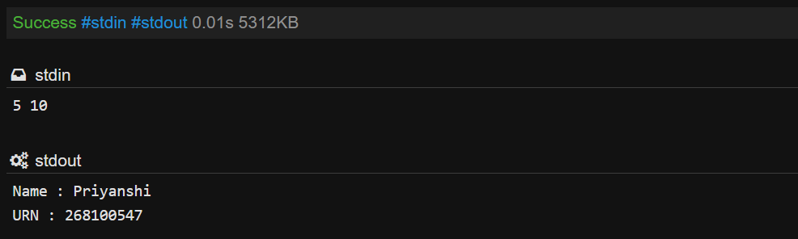

Q2. Calculating Area and Perimeter
Write a C program that accepts the length and breadth of a rectangle. Create calculate Rectangle() to calculate area and perimeter. Pass length and breadth by value, return the area, and use a pointer parameter to store the perimeter for the calling function. Display both results in main().
#include <stdio.h>

int calculateRectangle(int l, int b, int *perim) {
*perim = 2 * (l + b);
return l * b;
}
int main() {
printf("Name : Priyanshi\n");
printf("URN : 268100547\n");

int l = 5, b = 4, area, perim;
area = calculateRectangle(l, b, &perim);

printf("Area: %d, Perimeter: %d\n", area, perim);
return 0;
}

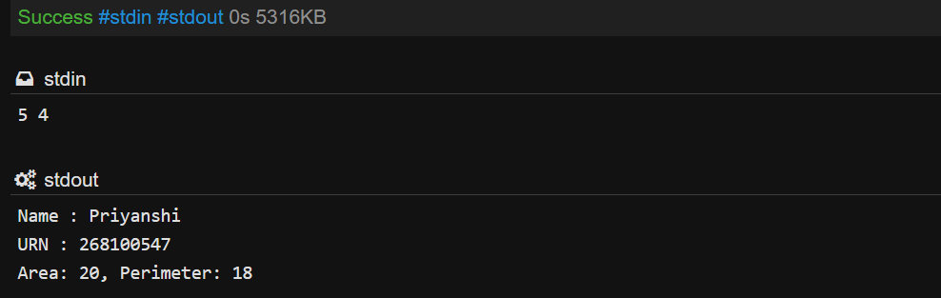

Q3. Updating Employee Salary
Accept an employee’s basic salary. Create calculateBonus(), which receives salary by value and calculates a 10% bonus. Create updateSalary(), which receives the salary through a pointer and increases the original salary by the bonus amount. Display the original salary, bonus, and updated salary. Explain the difference between the approaches.
#include <stdio.h>

float calculateBonus(float sal) {
return sal * 0.10;
}
void updateSalary(float *sal, float bonus) {
*sal += bonus;
}
int main() {
printf("Name : Priyanshi\n");
printf("URN : 268100547\n");

float sal = 20000;
float bonus = calculateBonus(sal);
updateSalary(&sal, bonus);
printf("Updated Salary: %.2f\n", sal);
return 0;
}



